

**A**

**Project Proposal**

**on**

**AI for Skin Disease Detection**

**Submitted By**

AMISHA BASNET (28903/078)

SAISA KOIRALA (28932/078)

SANDESH KHATIWADA (28936/078)

**Submitted To**

Er. Dhiraj Kumar Jha

Lecturer

Orchid International College

DEPARTMENT OF COMPUTER SCIENCE AND INFORMATION TECHNOLOGY

ORCHID INTERNATIONAL COLLEGE

**Table of Contents**

1 Introduction 1

2 Problem Statement 2

3 Objectives 3

4 Scope 3

5 Constraints 3

6 Algorithm Details 4

6.1 CNN (Convolutional Neural Network): 4

6.1.1 Feature Extraction 4

6.1.2 Classification 4

6.1.3 Purpose 4

6.2 MobileNet: 5

6.2.1 Architecture and Design 5

6.2.2 Performance Optimization 5

6.2.3 Transfer Learning for Skin Disease Detection 6

6.2.4 Purpose 6

6.3 DenseNet121: 6

6.3.1 Architecture and Design 6

6.3.2 Training Benefits 7

6.3.3 Performance in This Project 7

6.3.4 Transfer Learning Application 7

6.3.5 Purpose 7

7 Data Processing (Input – Processing – Output) 8

7.1 Input Stage: 8

7.2 Processing Stage: 8

7.3 Output Stage: 9

8 Testing Methodology 9

8.1 Evaluation Metrics: 9

9 Final Outcomes and Deliverables 10

9.1 Expected Outcome: 10

9.2 Deliverables: 10

9.3 Interface Design (Wireframe): 10

9.4 Feasibility: 11

# Introduction

Skin diseases are among the most prevalent health issues worldwide, affecting people of all ages, ethnicities, and regions. These conditions, ranging from common ailments like acne and eczema to more severe disorders such as melanoma and psoriasis, can significantly impact a person's physical health, emotional well-being, and quality of life. Despite their widespread occurrence, access to timely and accurate diagnosis remains a major challenge, particularly in rural or underserved areas where specialized dermatologists are scarce. As a result, many cases are either diagnosed late or misdiagnosed, leading to prolonged suffering, complications, or even life-threatening outcomes in severe cases like skin cancer.

Timely detection and diagnosis of skin diseases are essential for effective treatment and better health outcomes. However, traditional diagnostic methods often rely on visual inspections by experts, which can be time-consuming, subjective, and inconsistent. Moreover, manual diagnosis is not scalable to meet the demands of large populations, especially during peak healthcare burdens.

With the rapid advancements in Artificial Intelligence (AI) and Deep Learning technologies, there is a significant opportunity to bridge this diagnostic gap. AI-powered systems, particularly those based on image classification, have demonstrated remarkable capabilities in medical imaging applications. These systems can learn from vast datasets of skin images to recognize patterns and classify diseases with a level of consistency and speed that supports clinical decision-making.

This project aims to leverage the power of deep learning models to develop an AI-based skin disease detection tool. By utilizing a labeled dataset of dermatological images and implementing advanced models such as Convolutional Neural Networks (CNN), MobileNet, and DenseNet121, the project seeks to create a reliable and accessible diagnostic aid. The ultimate goal is to support early identification of skin conditions, improve patient outcomes, reduce the burden on healthcare professionals, and extend dermatological services to remote or under-resourced regions.

# Problem Statement

Skin disorders constitute a major portion of global health concerns, impacting millions of individuals across all age groups, ethnicities, and socioeconomic backgrounds. These conditions range from common issues like acne and eczema to more severe ailments such as melanoma and psoriasis. Despite their prevalence, timely and accurate diagnosis remains out of reach for many, particularly in rural and underserved regions where access to specialized dermatological care is limited or completely unavailable. This lack of accessibility often results in delayed treatment, misdiagnosis, or even complete neglect of symptoms, which can escalate into more serious health complications. Traditional diagnostic practices are heavily dependent on dermatologists' expertise, involving visual examination and manual interpretation of skin lesions. However, these methods are not only time-consuming and resource-intensive but also subject to human error and variability in judgment, which further complicates consistent diagnosis. In this context, the integration of artificial intelligence (AI), particularly computer vision and deep learning, offers a transformative opportunity to address these challenges. With the ability to learn from vast datasets of medical images, AI-powered systems can analyze skin conditions rapidly, accurately, and consistently. This project aims to harness such capabilities by developing a robust, deep learning-based image classification model capable of detecting and categorizing various skin diseases from clinical photographs. The tool is envisioned as a supportive diagnostic assistant that can augment the efforts of healthcare professionals, especially in areas where specialists are scarce. By providing immediate, reliable preliminary assessments, it can help prioritize urgent cases, reduce the burden on healthcare infrastructure, and expand access to quality care. Furthermore, it underscores the broader societal and technological significance of AI in revolutionizing healthcare delivery, reducing inequities, and promoting early intervention and better health outcomes for all.

# Objectives

To build a deep learning-based classification model for skin diseases using image data.

1. To build and train deep learning models (CNN, MobileNet, DenseNet121) for accurate skin disease classification.
2. To compare the performance of these models using evaluation metrics such as accuracy, loss, and confusion matrix.
3. To deploy the model through a simple web interface for user interaction.

# Scope

The scope of this project is specifically limited to the classification of skin diseases using image data alone. The system is designed to take static clinical images as input and predict the most likely skin disease category based on visual features extracted through deep learning models. While this approach supports early detection and awareness, it does not include real-time diagnosis functionalities or integration with external medical devices such as dermatoscopes or mobile sensors. Additionally, the system is intended as a standalone diagnostic aid and does not involve live patient monitoring or clinical workflow automation at this stage.

# Constraints

1. The system assumes clear and standardized image input.
2. Model performance relies heavily on dataset quality and diversity.
3. It is designed as an assistive tool and not a certified diagnostic product.

# Algorithm Details

## CNN (Convolutional Neural Network):

### **Feature Extraction**

CNNs utilize multiple convolutional layers to automatically detect and learn important visual features from the input skin lesion images. These features include fundamental elements such as edges, textures, shapes, and color patterns, which are critical for distinguishing different types of skin diseases. Pooling layers are applied to reduce spatial dimensions, helping the model focus on the most relevant features while reducing computational complexity.

### **Classification**

After the feature extraction stage, the learned representations are flattened and passed through one or more fully connected (dense) layers. These layers combine the extracted features to make predictions by classifying each image into one of the predefined skin disease categories. The final output layer typically uses a softmax activation function to provide probabilities for each disease class.

### **Purpose**

The CNN serves as a baseline, custom-designed model specifically created to understand and classify skin disease images. It provides a foundation for comparing more complex and pretrained architectures. Despite its simplicity, it is effective for learning fundamental image features and offer insight into how convolution neural networks process medical images in the context of skin disease detection.

## MobileNet:

### **Architecture and Design**

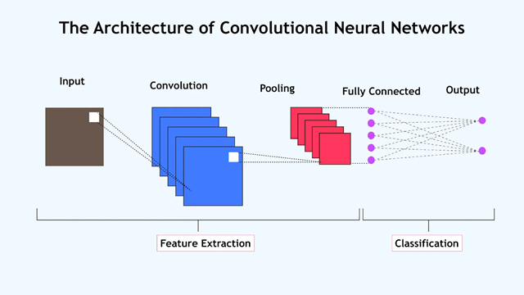MobileNet is a lightweight convolutional neural network specifically designed for efficient performance on mobile and embedded devices. Unlike traditional CNNs, it uses depth wise separable convolutions, which split the convolution operation into two steps-depthwise and pointwise-significantly reducing the number of parameters and computational cost while maintaining accuracy.

Figure 1: Architecture of CNN

### **Performance Optimization**

Due to its compact size and low latency, MobileNet is highly optimized for real-time applications and resource-constrained environments, such as smartphones or tablets. This makes it ideal for medical diagnostic tools that require portability and quick responses.

### **Transfer Learning for Skin Disease Detection**

In this project, a pre-trained MobileNet model (trained on the ImageNet dataset) is adapted through transfer learning. By fine-tuning the final layers with the skin disease dataset, the model learns to identify and classify various skin conditions with high efficiency.

### **Purpose**

MobileNet serves as a high-speed alternative to heavy models, making the AI system more responsive and suitable for real-time usage scenarios. It allows the application to maintain strong accuracy while being practical for deployment in low-power devices and remote healthcare settings.

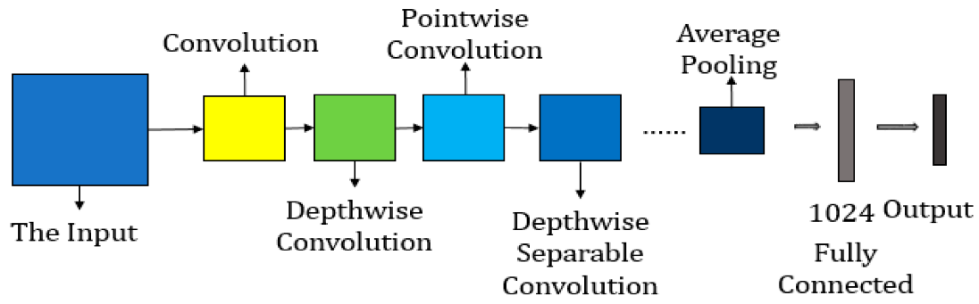

Figure 2: Architecture of MobileNet

## DenseNet121:

### **Architecture and Design**

DenseNet121 (Densely Connected Convolutional Network) is a deep pre-trained model that introduces dense connectivity between layers, meaning each layer receives input from all previous layers and passes its feature maps to all subsequent layers. This dense feature reuse enhances gradient flow, strengthens feature propagation, and leads to more compact and efficient models.

### **Training Benefits**

DenseNet121 helps mitigate vanishing gradient problems that can occur in very deep networks by ensuring better gradient flow through the dense connections. This leads to more effective learning, faster convergence, and improved overall performance in complex classification tasks.

### **Performance in This Project**

In our experiments, DenseNet121 delivered the highest classification accuracy among the three models (CNN, MobileNet, and DenseNet121). Its depth and architectural efficiency make it highly capable of capturing subtle differences between various skin disease patterns.

### **Transfer Learning Application**

The model was initialized with weights pre-trained on the ImageNet dataset and fine-tuned using the skin disease dataset. This approach allowed the network to leverage general image features while adapting to the specific task of skin disease classification.

### **Purpose**

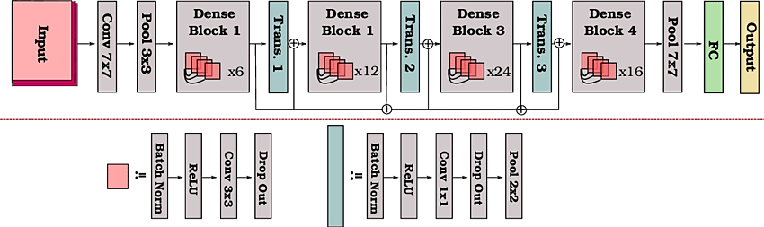DenseNet121 serves as the most accurate and powerful model in our system, demonstrating the potential of deep learning in achieving reliable medical image diagnostics.

Figure 3: Architecture of DenseNet121

# Data Processing (Input – Processing – Output)

## Input Stage:

* The dataset used is the Skin Disease Classification [Image Dataset] from Kaggle, which contains dermatological images.
* It consists of approximately 900 images classifying 9 skin disease types such as melanoma, acne, eczema, psoriasis, bullous disease, and tinea (ringworm).
* Images are in JPEG format, include three color channels (RGB), and have varying resolutions.
* The dataset is diverse, including different skin tones, lighting conditions, and stages of disease progression.

## Processing Stage:

* Each image is resized to 240 by 240 pixels to maintain uniformity and match the input requirements of the deep learning models.
* Pixel values are normalized to a range between 0 and 1 to ensure stable and efficient model training.
* Disease category labels are first converted into numerical form and then one-hot encoded for use in multi-class classification.
* The dataset is split into training, validation, and test sets. The training set is used for learning, the validation set helps monitor training and tune hyperparameters, and the test set evaluates final performance.

## Output Stage:

* The final result is a cleaned and preprocessed dataset that is structured and optimized for use in deep learning.
* These steps help the model learn more effectively, improving accuracy and generalization across skin disease categories.
* The processed data supports multi-class classification, enabling the model to distinguish among the 9 diseases accurately.

# Testing Methodology

* The dataset includes 900 images to classify 9 diseases (80:20 train-test split).
* The model was trained on the training set and validated on a hold-out subset to monitor performance.
* Final testing was performed on the unseen test set to evaluate generalization.

## Evaluation Metrics:

* Accuracy: Represents the proportion of correctly predicted skin disease images out of the total number of predictions. It gives an overall sense of how well the model performs but may not fully capture performance in imbalanced datasets.
* Loss: A numerical measure that quantifies how far the model’s predictions are from the actual labels. Lower loss indicates better performance. It is used during training to guide the optimization process.
* Confusion Matrix: A table that provides a detailed breakdown of the model’s predictions for each skin disease category. It helps identify which classes are frequently misclassified and highlights class-wise performance.

# Final Outcomes and Deliverables

## Expected Outcome:

The primary expected outcome of this project is to develop a reliable and accurate AI-based system capable of classifying various skin conditions from input images. The system should be able to process clinical images of skin lesions and identify the most probable disease category with high precision. By leveraging deep learning models such as CNN, MobileNet, and DenseNet121, the tool aims to assist healthcare professionals and individuals in making preliminary assessments. Ultimately, the system should demonstrate strong performance in terms of classification accuracy and provide a foundation for potential real-world applications in dermatology support tools.

## Deliverables:

* Deep learning model trained on a labeled skin disease image dataset
* Web-based interface allowing users to upload skin condition images
* Automated prediction of skin disease from the uploaded image
* Display of prediction label along with a confidence score
* End-to-end system demonstrating practical use of AI in medical diagnostics

## Interface Design (Wireframe):

* Home Page: Upload form for images
* Result Page: Displays predicted disease, image preview, and explanation

## Feasibility:

* Pre-trained models reduce training time
* Public dataset is labeled and sufficient for our goals
* Flask-based web interface can be developed within the project timeline

**Conclusion**

The proposed project aims to develop an AI-based system for accurate and timely classification of skin diseases using deep learning models. By leveraging models like CNN, MobileNet, and DenseNet121, the system can analyze medical images and assist in early detection. With access to a comprehensive dataset, the project ensures a strong foundation for training and evaluation. The use of transfer learning and image preprocessing techniques enhances performance and generalization.

This solution has the potential to reduce diagnostic delays, especially in regions with limited access to dermatologists. It supports healthcare providers by offering a consistent, fast, and scalable diagnostic aid. The combination of technical feasibility and real-world relevance makes this project both achievable and impactful within the course timeline.